**TASK 1**

<!DOCTYPE html>

<html lang="en">

<head>

<meta charset="UTF-8">

<meta name="viewport" content="width=device-width, initial-scale=1.0">

<title>Document</title>

</head>

<body>

<script>

alert("Hello World");

</script>

</body>

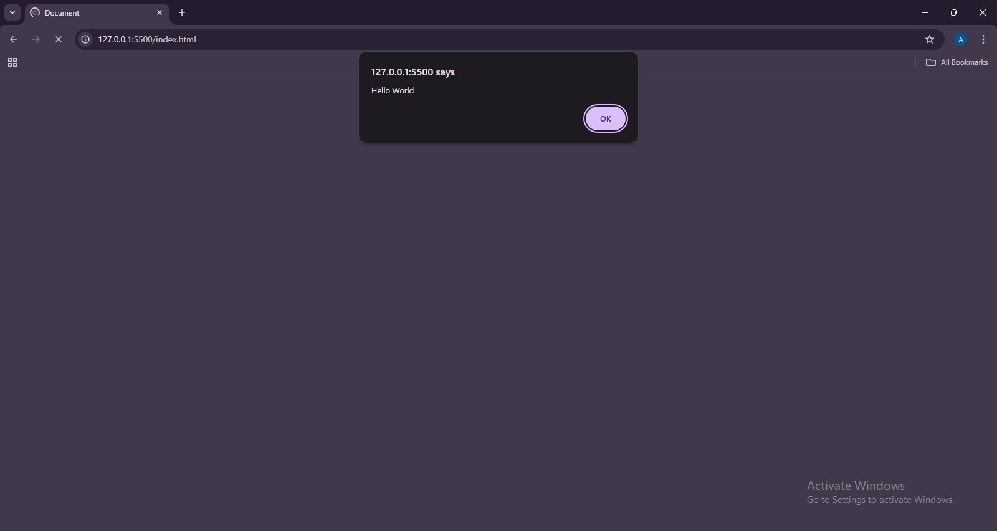</html>

**TASK 2**

<!DOCTYPE html>

<html lang="en">

<head>

<meta charset="UTF-8">

<meta name="viewport" content="width=device-width, initial-scale=1.0">

<title>Document</title>

</head>

<body>

<script>

let num1 = 4; let num2 = 5;

console.log(num1 + num2); console.log(num2 - num2); console.log(num1 * num2); console.log(num1 / num2); console.log(num1 ** num2);

</script>

</body>

</html>

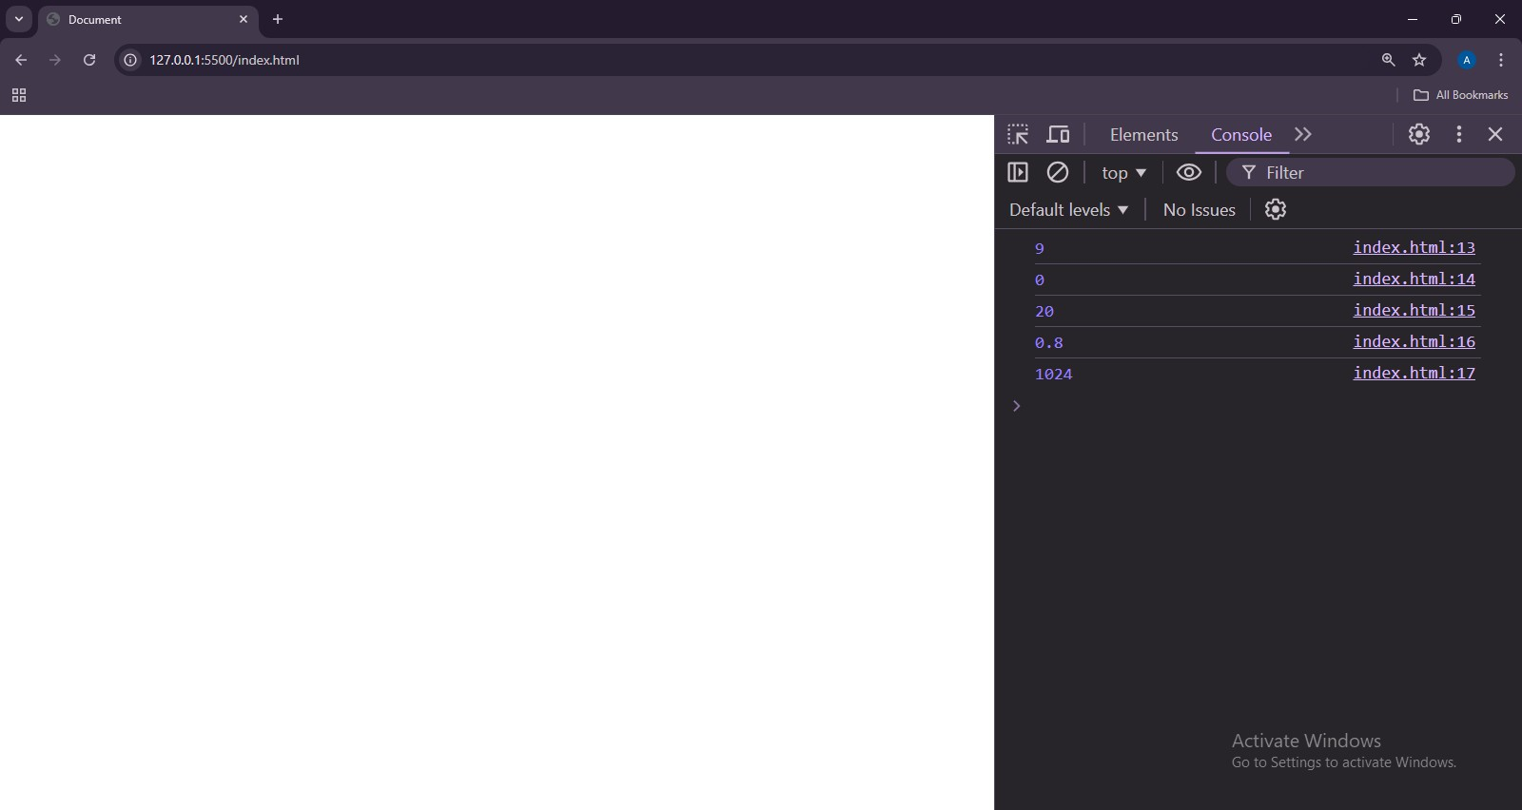

**TASK 3**

<!DOCTYPE html>

<html lang="en">

<head>

<meta charset="UTF-8">

<meta name="viewport" content="width=device-width, initial-scale=1.0">

<title>Document</title>

</head>

<body>

<script>

let firstName = "John"; let lastName = "Cena";

console.log(firstName + lastName);

</script>

</body>

</html>

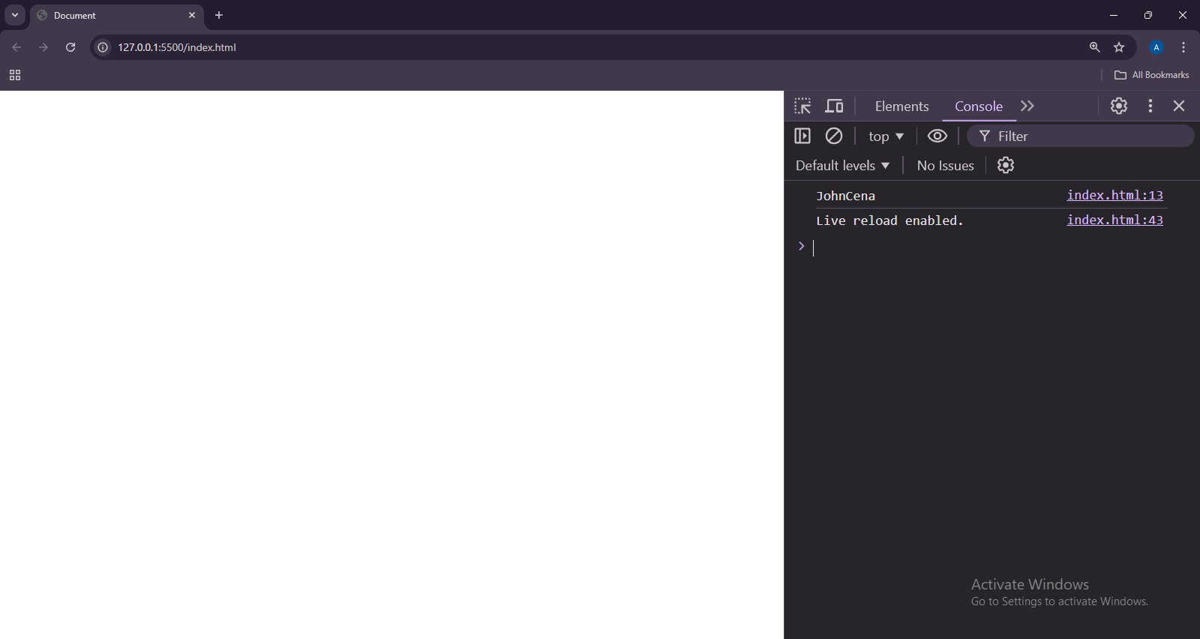

**TASK 4**

<!DOCTYPE html>

<html lang="en">

<head>

<meta charset="UTF-8">

<meta name="viewport" content="width=device-width, initial-scale=1.0">

<title>Document</title>

</head>

<body>

<script>

let firstName = "John"; let number = 5656;

let isAlive = false; let float = 56.56; let notdec;

console.log(typeof firstName); console.log(typeof(number)); console.log(typeof isAlive); console.log(typeof(float)); console.log(typeof notdec);

</script>

</body>

</html>

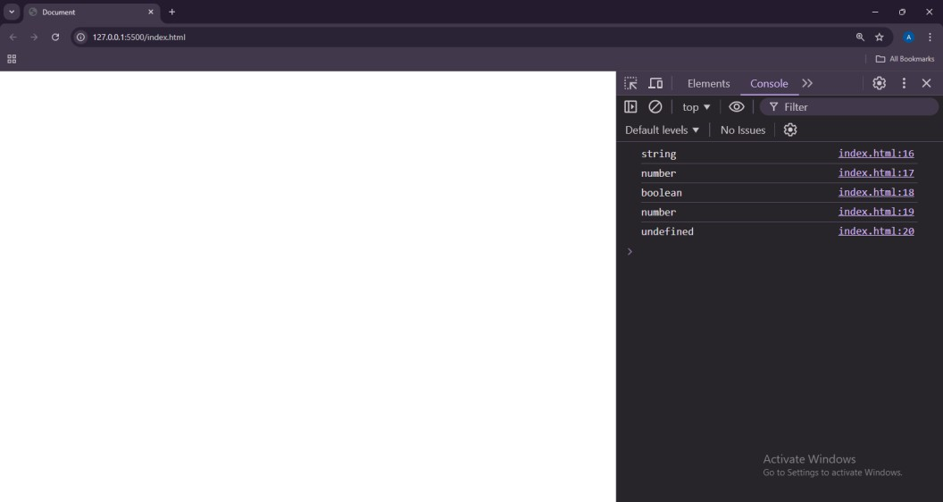

**TASK 5**

<!DOCTYPE html>

<html lang="en">

<head>

<meta charset="UTF-8">

<meta name="viewport" content="width=device-width, initial-scale=1.0">

<title>Document</title>

</head>

<body>

<script>

let firstName = "John"; let number = 5656;

let isAlive = false; let float = 56.56; let notdec;

console.log(typeof firstName); console.log(typeof(number)); console.log(typeof isAlive); console.log(typeof(float)); console.log(typeof notdec);

</script>

</body>

</html>

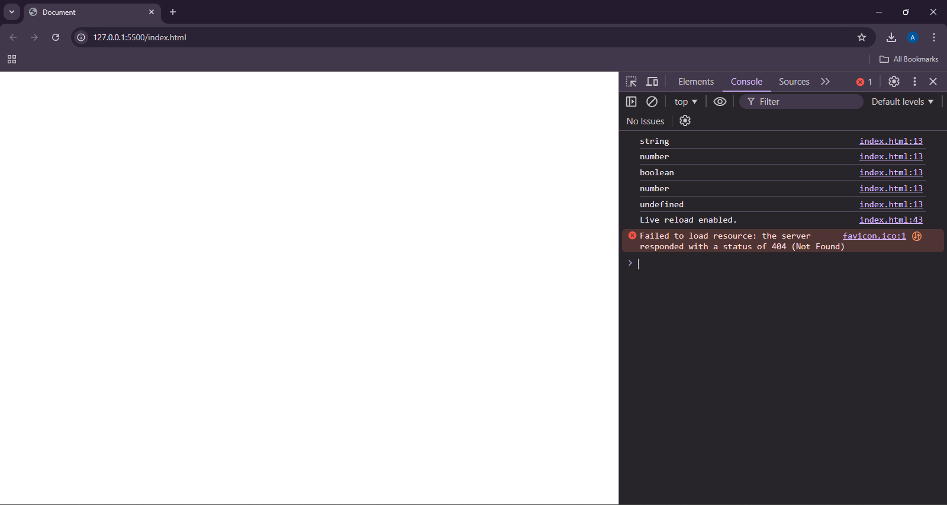

**TASK 6**

<!DOCTYPE html>

<html lang="en">

<head>

<meta charset="UTF-8">

<meta name="viewport" content="width=device-width, initial-scale=1.0">

<title>Document</title>

</head>

<body>

<script>

// This is single line comment

/* This is multi

line comment

*/

</script>

</body>

</html>

**TASK 7**

<!DOCTYPE html>

<html lang="en">

<head>

<meta charset="UTF-8">

<meta name="viewport" content="width=device-width, initial-scale=1.0">

<title>Document</title>

</head>

<body>

<script>

console.log(5 + 7);

console.log("Hello World");

console.log(56 * 56);

console.log("scooby doo")

</script>

</body>

</html>

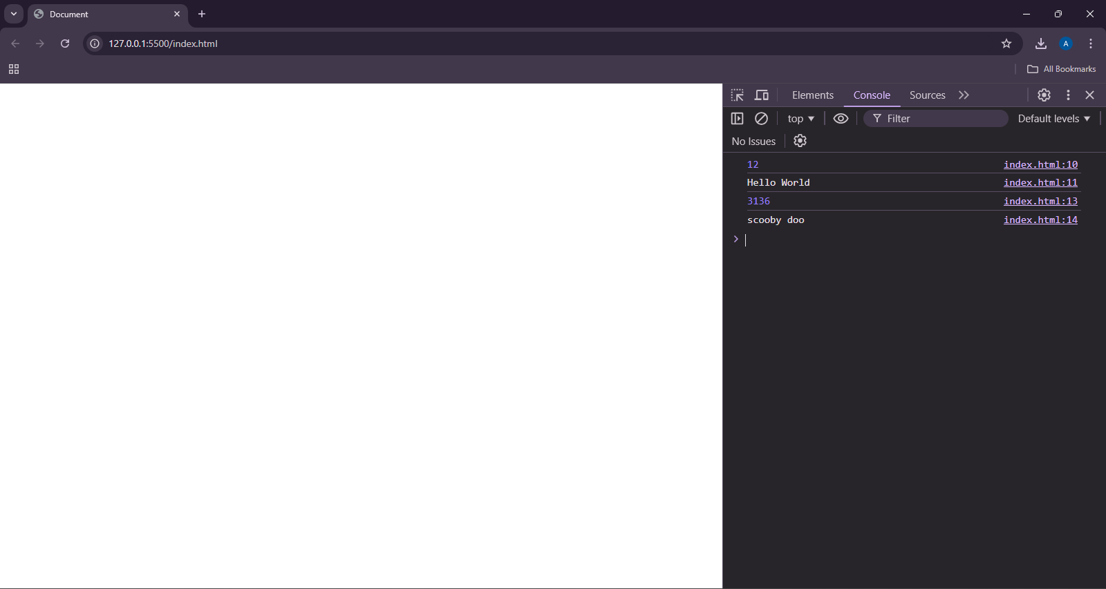

**TASK 8**

<!DOCTYPE html>

<html lang="en">

<head>

<meta charset="UTF-8">

<meta name="viewport" content="width=device-width, initial-scale=1.0">

<title>Document</title>

</head>

<body>

<script>

let n = 4;

for(let i = 0; i < n; i++){

for(let j = 0; j < n; j++){

document.write(Math.max(Math.abs(i - n) + Math.abs(j - n)))

}

document.write("<br>");

}

</script>

</body>

</html>

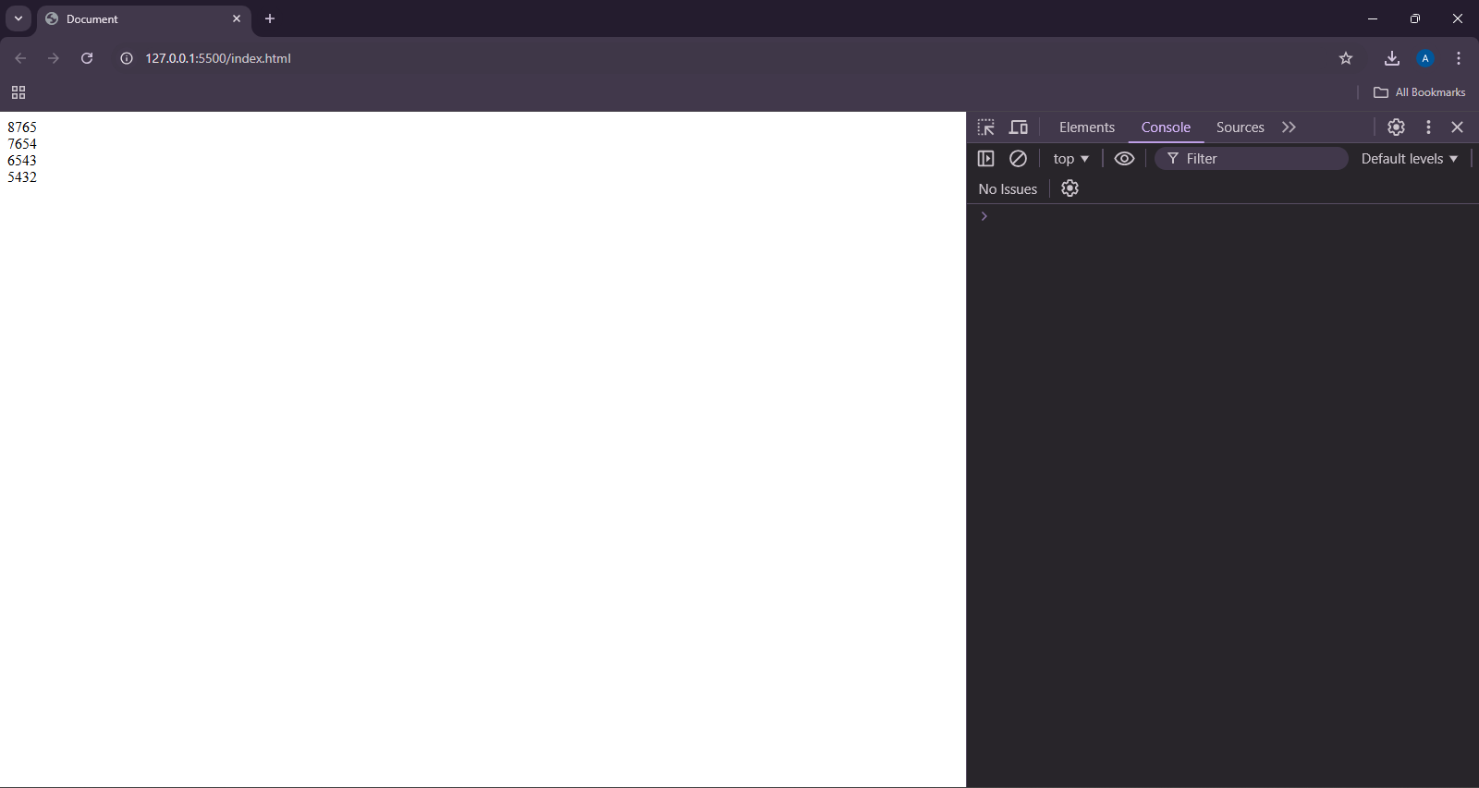

**TASK 9**

<!DOCTYPE html>

<html lang="en">

<head>

<meta charset="UTF-8">

<meta name="viewport" content="width=device-width, initial-scale=1.0">

<title>Document</title>

</head>

<body>

<script>

let a = 5, b = 6, c = 7;

let arr = [a, b, c];

for(let num of arr){

document.write(num + " ");

}

</script>

</body>

</html>

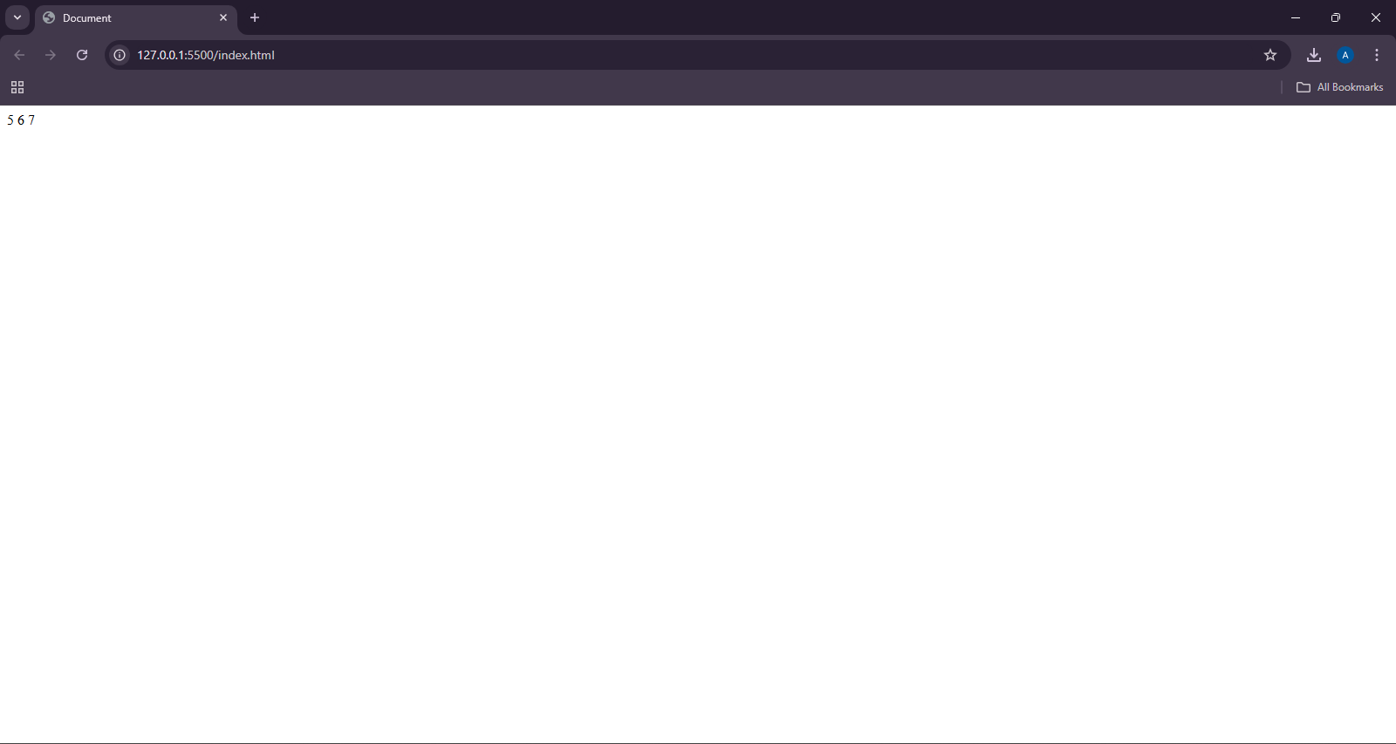

**TASK 10**

<script>

document.write("JAVASCRIPT OUTSIDE HTML TAG" + "<br>");

</script>

<!DOCTYPE html>

<html lang="en">

<head>

<meta charset="UTF-8">

<meta name="viewport" content="width=device-width, initial-scale=1.0">

<title>Document</title>

</head>

<body>

<script>

document.write("JAVASCRIPT INSIDE BODY TAG");

</script>

</body>

</html>

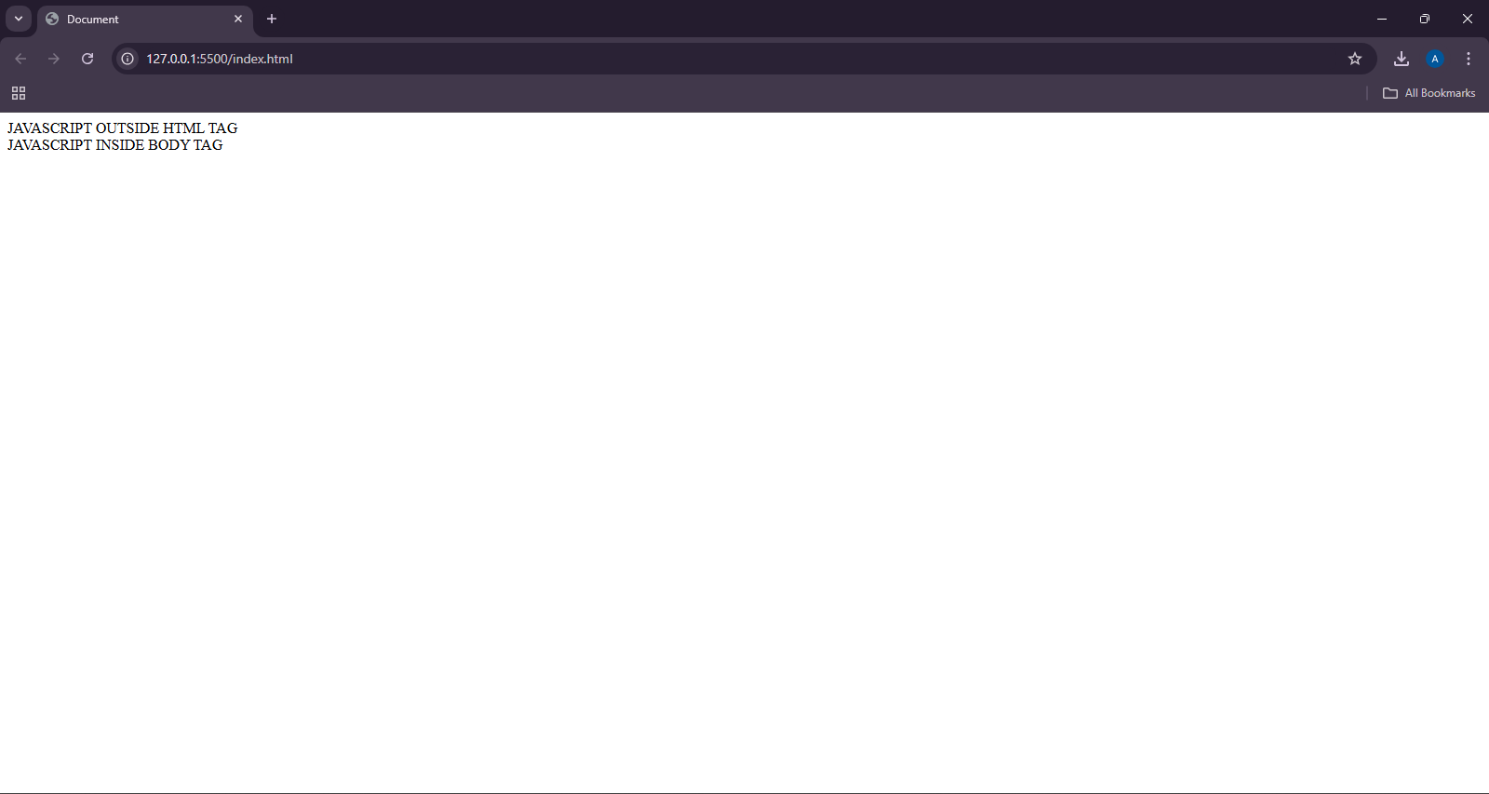

**TASK 11**

<!DOCTYPE html>

<html lang="en">

<head>

<meta charset="UTF-8">

<meta name="viewport" content="width=device-width, initial-scale=1.0">

<title>Document</title>

</head>

<body>

<script>

x = 10;

document.write(x);

</script>

</body>

</html>



**TASK 12**

<!DOCTYPE html>

<html lang="en">

<head>

<meta charset="UTF-8">

<meta name="viewport" content="width=device-width, initial-scale=1.0">

<title>Document</title>

</head>

<body>

<script>

'use strict'

x = 10;

document.write(x);

</script>

</body>

</html>

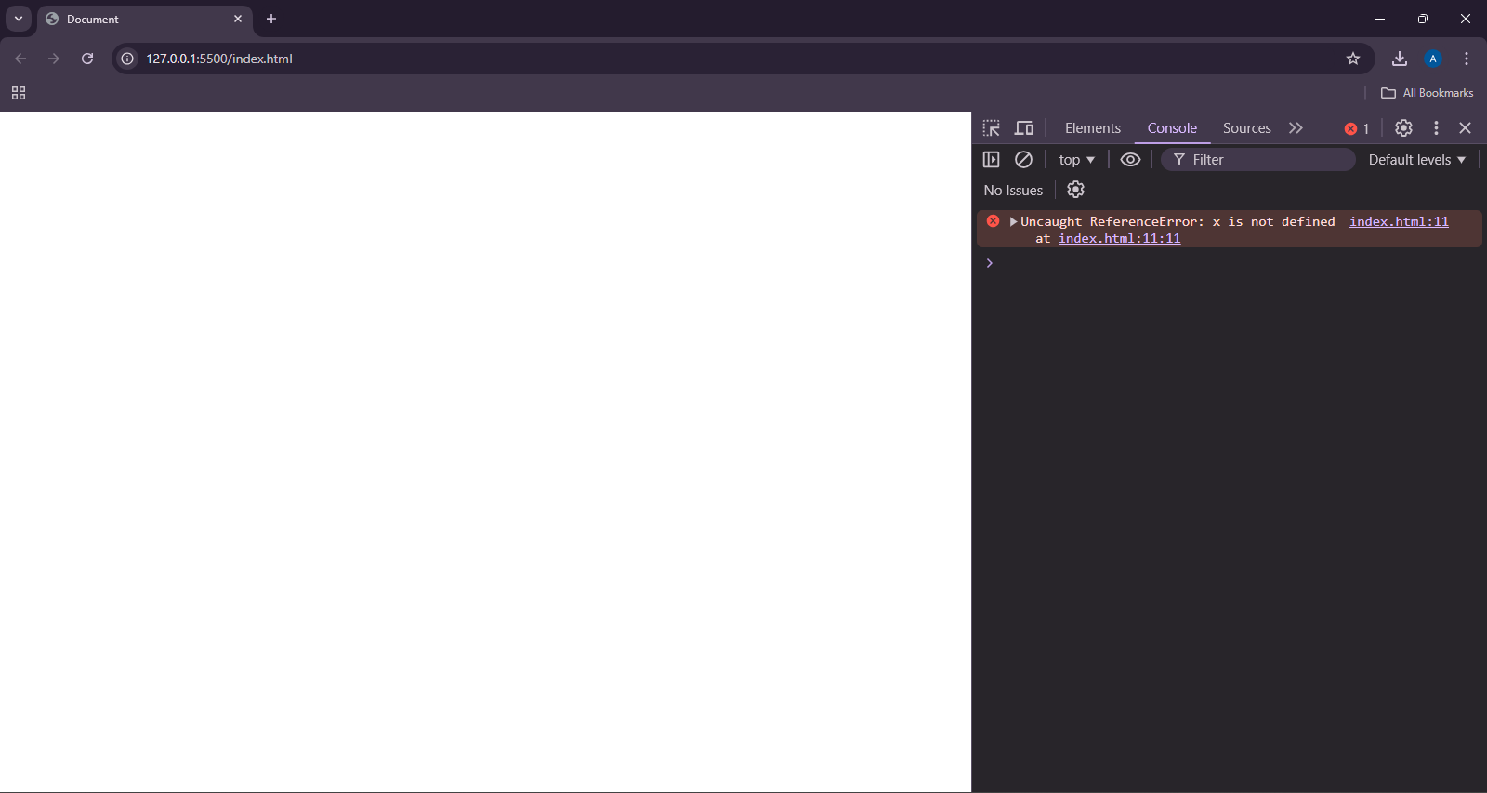

**TASK 13**

<!DOCTYPE html>

<html lang="en">

<head>

<meta charset="UTF-8">

<meta name="viewport" content="width=device-width, initial-scale=1.0">

<title>Document</title>

</head>

<body>

<script>

'use strict'

let x = 10;

delete x;

</script>

</body>

</html>

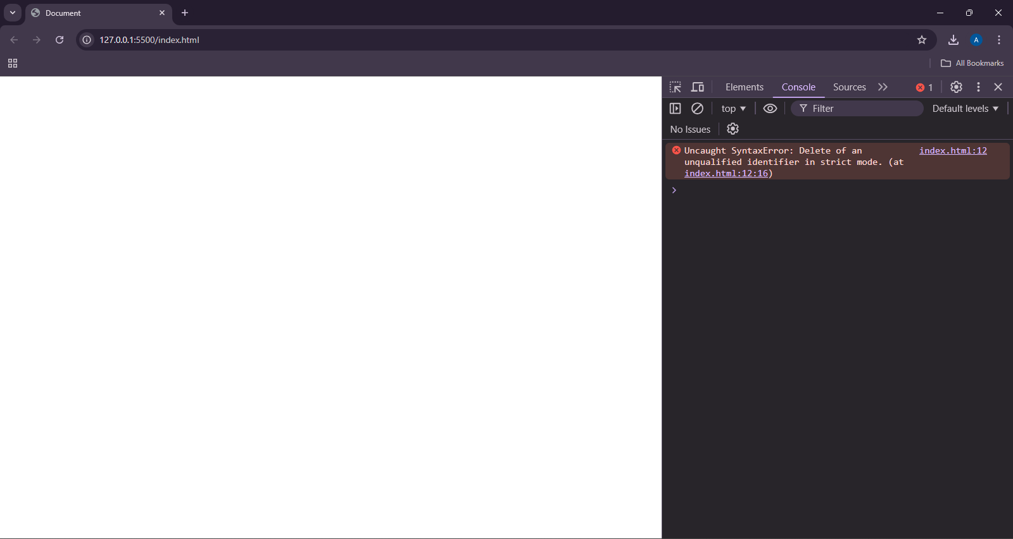

**TASK 14**

<!DOCTYPE html>

<html lang="en">

<head>

<meta charset="UTF-8">

<meta name="viewport" content="width=device-width, initial-scale=1.0">

<title>Document</title>

</head>

<body>

<script>

x = 10;

document.write(x + "<br>");

'use strict';

y = 12;

document.write(y + "<br>");

</script>

</body>

</html>

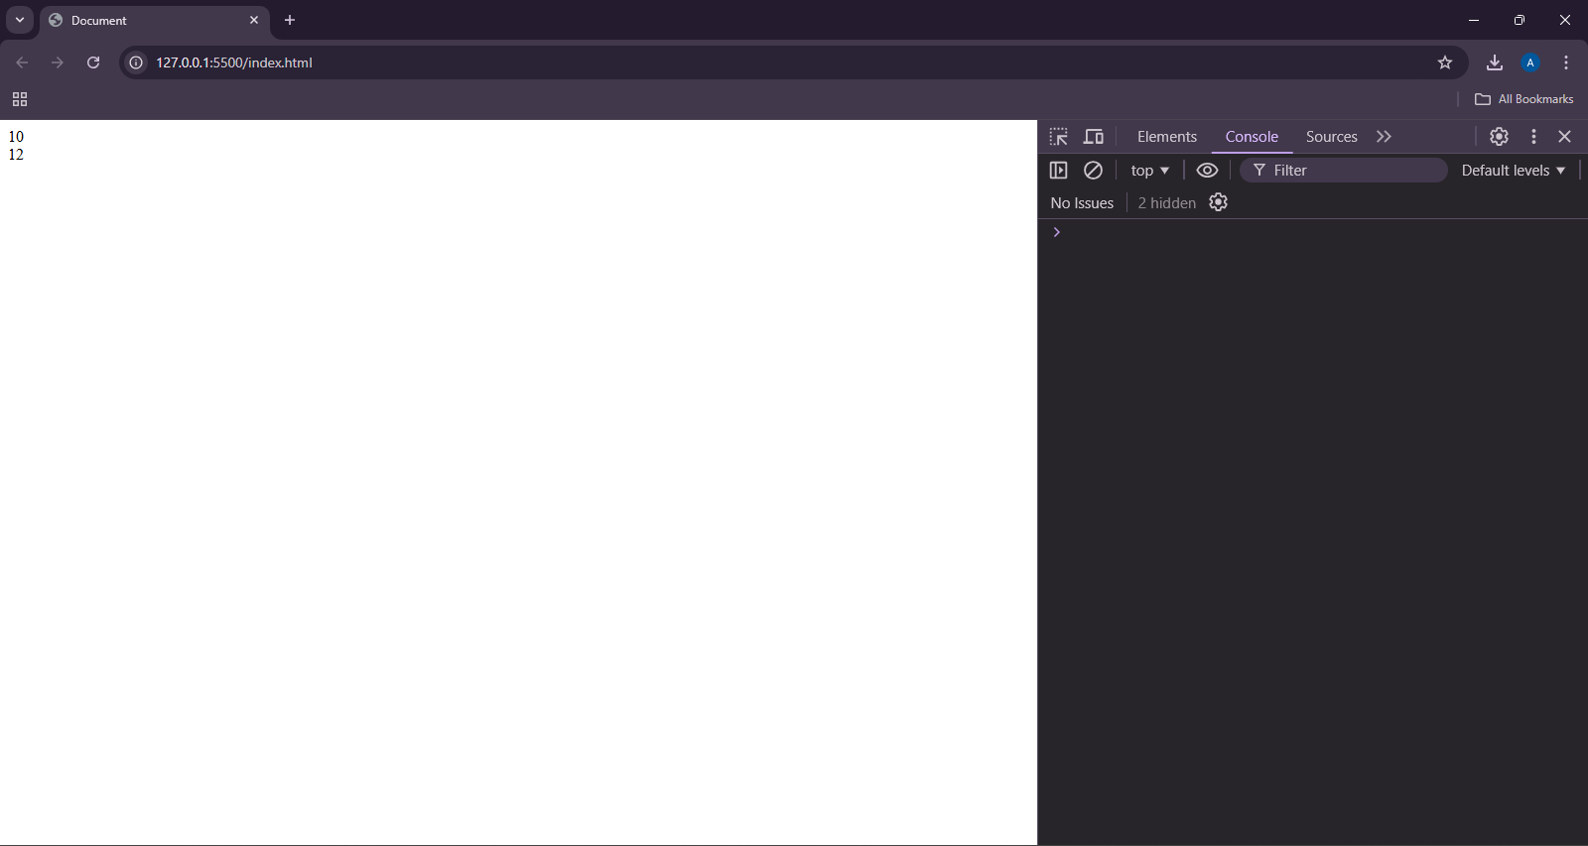

**TASK 15**

<!DOCTYPE html>

<html lang="en">

<head>

<meta charset="UTF-8">

<meta name="viewport" content="width=device-width, initial-scale=1.0">

<title>Document</title>

</head>

<body>

<script>

'use strict';

let function = 56;

console.log(function)

</script>

</body>

</html>

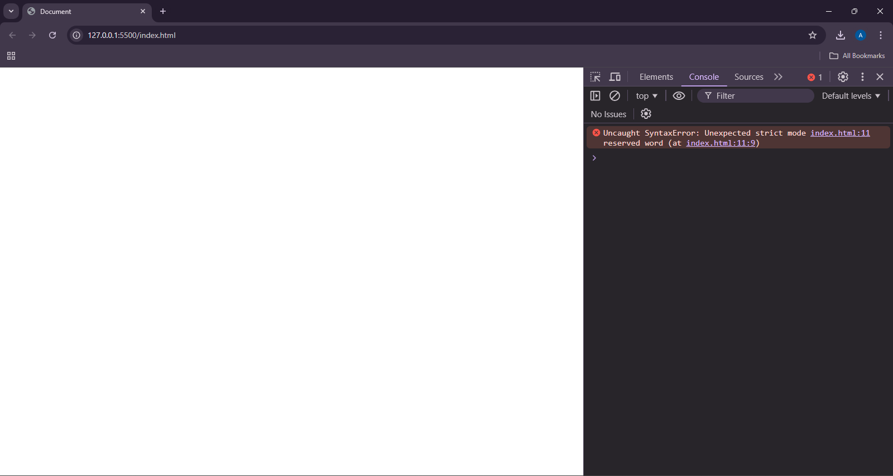

**TASK 16**

<!DOCTYPE html>

<html lang="en">

<head>

<meta charset="UTF-8">

<meta name="viewport" content="width=device-width, initial-scale=1.0">

<title>Document</title>

</head>

<body>

<script>

let a = 10;

var b = 56;

const C = 3.14;

</script>

</body>

</html>

**TASK 17**

<!DOCTYPE html>

<html lang="en">

<head>

<meta charset="UTF-8">

<meta name="viewport" content="width=device-width, initial-scale=1.0">

<title>Document</title>

</head>

<body>

<script>

const PI = 3.14;

PI = 22 / 7;

console.log(PI);

</script>

</body>

</html>

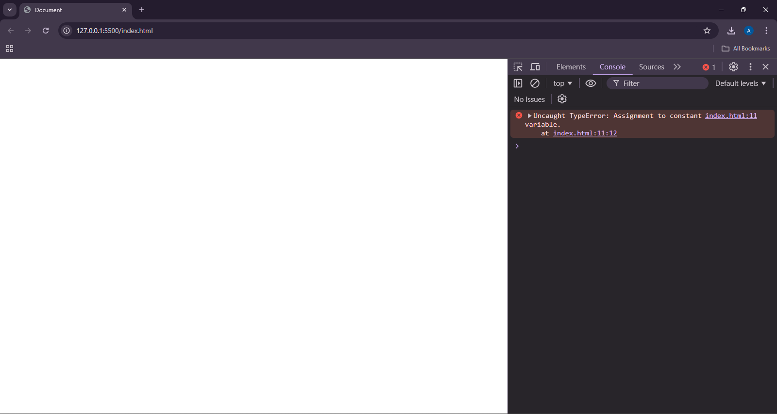

**TASK 18**

<!DOCTYPE html>

<html lang="en">

<head>

<meta charset="UTF-8">

<meta name="viewport" content="width=device-width, initial-scale=1.0">

<title>Document</title>

</head>

<body>

<script>

let pi;

console.log(pi);

</script>

</body>

</html>

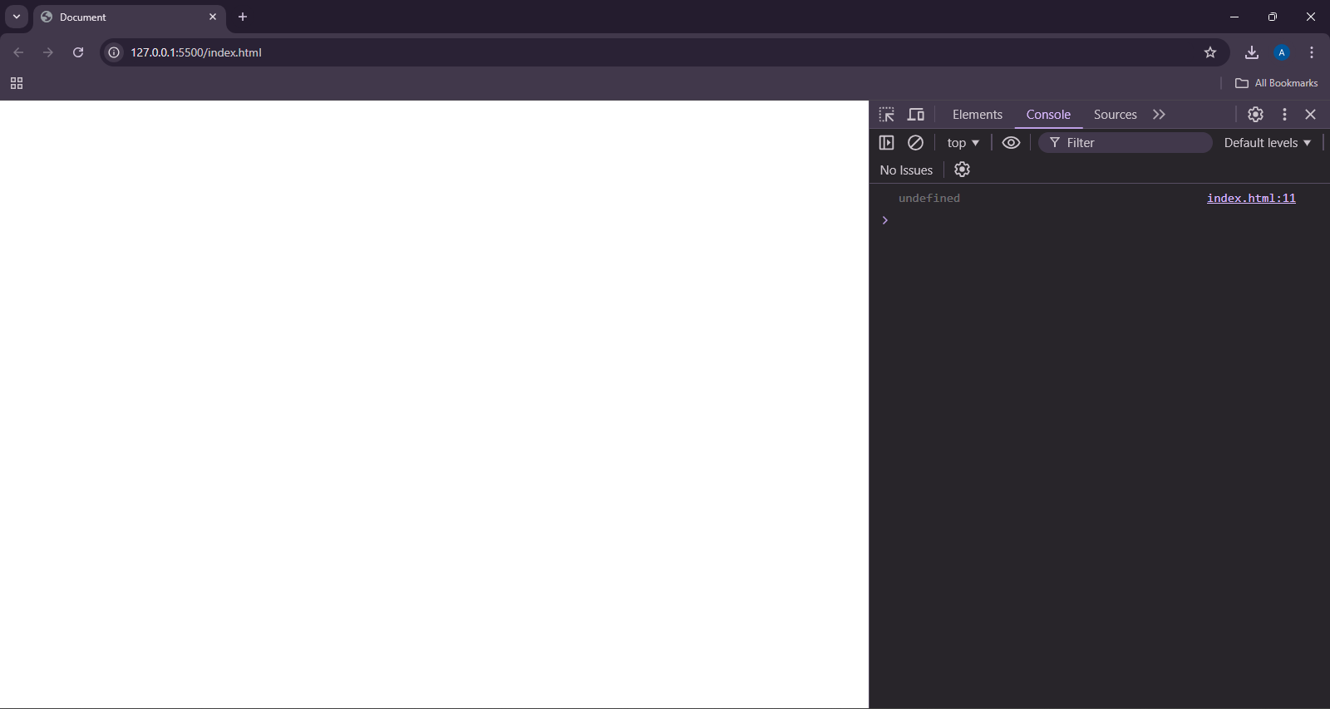

**TASK 19**

<!DOCTYPE html>

<html lang="en">

<head>

<meta charset="UTF-8">

<meta name="viewport" content="width=device-width, initial-scale=1.0">

<title>Document</title>

</head>

<body>

<script>

let pi = 3.14;

let name = "JOHN";

let isAlive = false;

console.log(typeof pi);

console.log(typeof(name));

console.log(typeof isAlive);

</script>

</body>

</html>

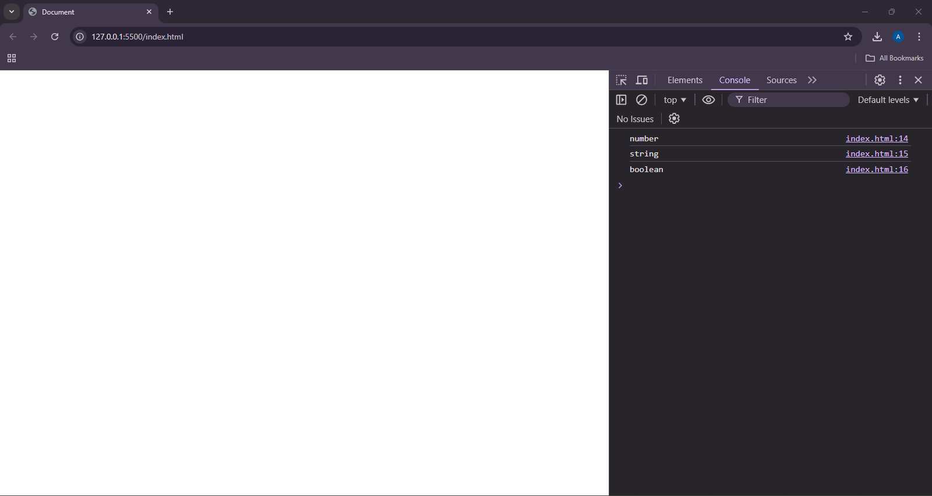

**TASK 20**

<!DOCTYPE html>

<html lang="en">

<head>

<meta charset="UTF-8">

<meta name="viewport" content="width=device-width, initial-scale=1.0">

<title>Document</title>

</head>

<body>

<script>

const person = {

name: "JOHN",

age: 28

}

const { name: fullname } = person;

</script>

</body>

</html>

**TASK 21**

<!DOCTYPE html>

<html lang="en">

<head>

<meta charset="UTF-8">

<meta name="viewport" content="width=device-width, initial-scale=1.0">

<title>Document</title>

</head>

<body>

<script>

let name = "JOHN";

let age = 18;

let isAlive = false;

let nodefined;

let nonull = null;

</script>

</body>

</html>

**TASK 22**

<!DOCTYPE html>

<html lang="en">

<head>

<meta charset="UTF-8">

<meta name="viewport" content="width=device-width, initial-scale=1.0">

<title>Document</title>

</head>

<body>

<script>

let name = "JOHN";

let age = 18;

let isAlive = false;

let nodefined;

let nonull = null;

console.log(typeof name);

console.log(typeof age);

console.log(typeof isAlive);

console.log(typeof nodefined);

console.log(typeof nonull);

</script>

</body>

</html>

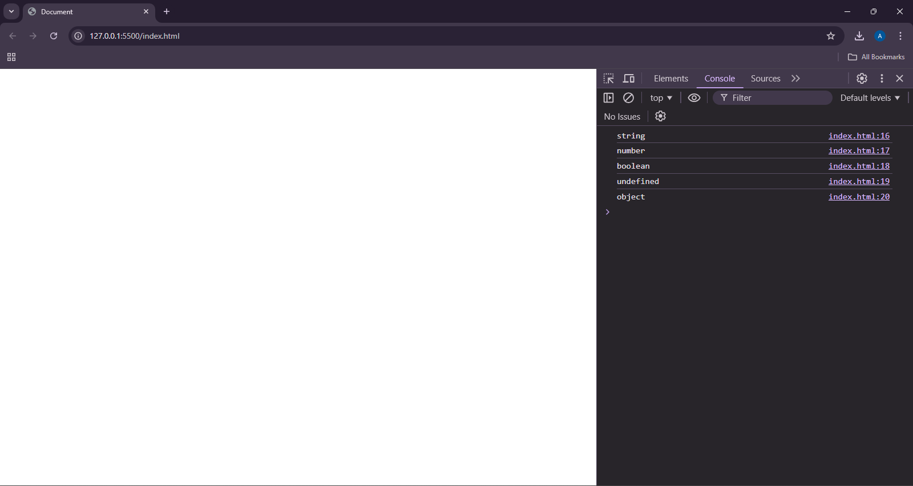

**TASK 23**

<!DOCTYPE html>

<html lang="en">

<head>

<meta charset="UTF-8">

<meta name="viewport" content="width=device-width, initial-scale=1.0">

<title>Document</title>

</head>

<body>

<script>

let name = "JOHN";

let age = 18;

let isAlive = false;

let nodefined;

let nonull = null;

console.log(typeof name);

console.log(typeof age);

console.log(typeof isAlive);

console.log(typeof nodefined);

console.log(typeof nonull);

</script>

</body>

</html>

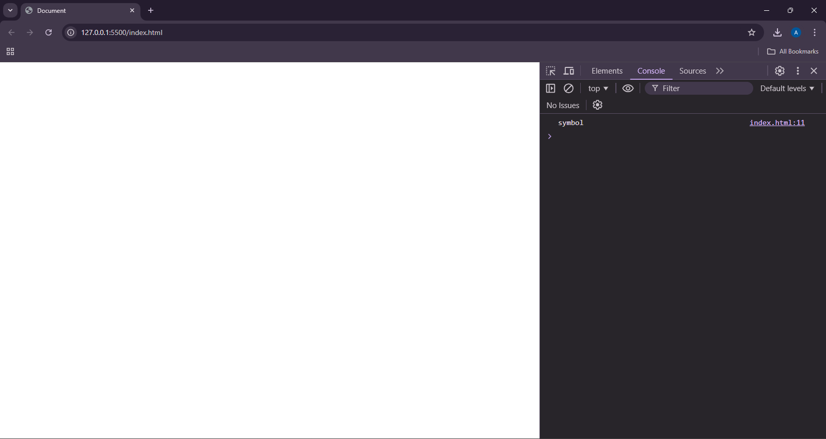

**TASK 24**

<!DOCTYPE html>

<html lang="en">

<head>

<meta charset="UTF-8">

<meta name="viewport" content="width=device-width, initial-scale=1.0">

<title>Document</title>

</head>

<body>

<script>

let nonull = null;

console.log(typeof nonull);

</script>

</body>

</html>

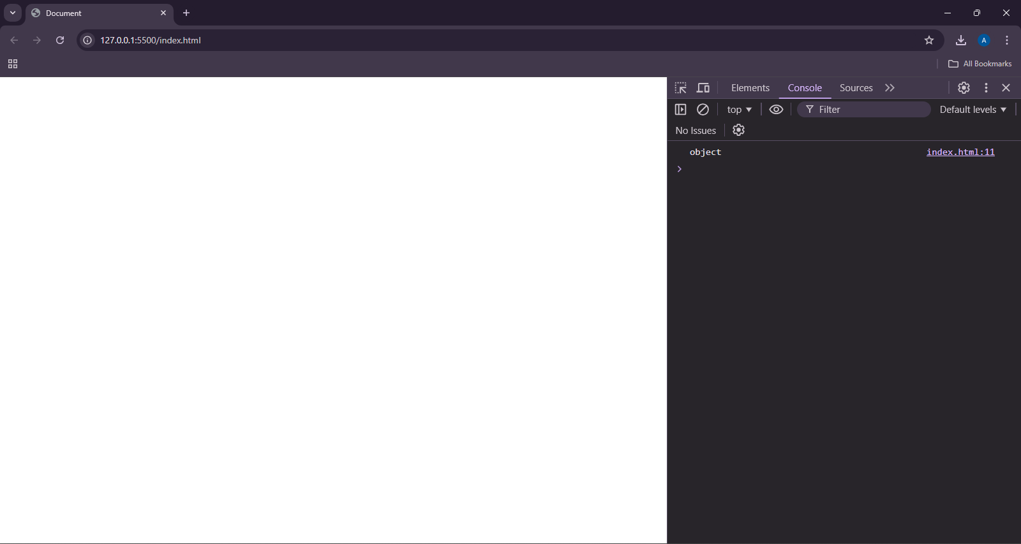

**TASK 25**

<!DOCTYPE html>

<html lang="en">

<head>

<meta charset="UTF-8">

<meta name="viewport" content="width=device-width, initial-scale=1.0">

<title>Document</title>

</head>

<body>

<script>

var i = 0, n = 10;

for(i = 0; i < n; i++){

}

console.log(i);

for(let j = 0; j < n; j++){

}

console.log(j);

</script>

</body>

</html>

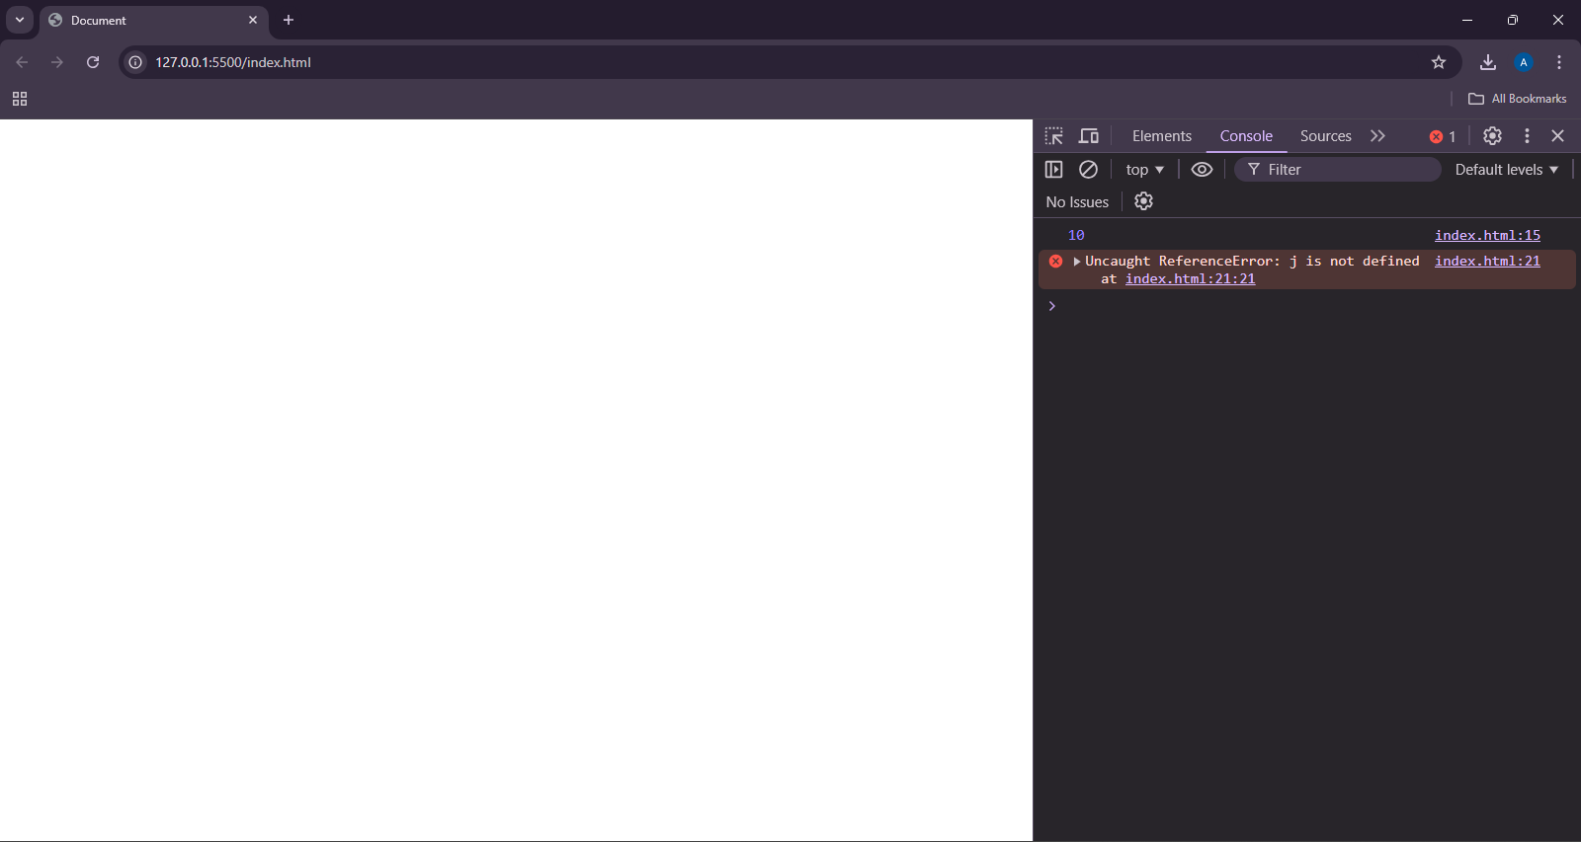

**TASK 26**

<!DOCTYPE html>

<html lang="en">

<head>

<meta charset="UTF-8">

<meta name="viewport" content="width=device-width, initial-scale=1.0">

<title>Document</title>

</head>

<body>

<script>

let name = "JOHN";

let nan = Number(name);

console.log(nan);

</script>

</body>

</html>

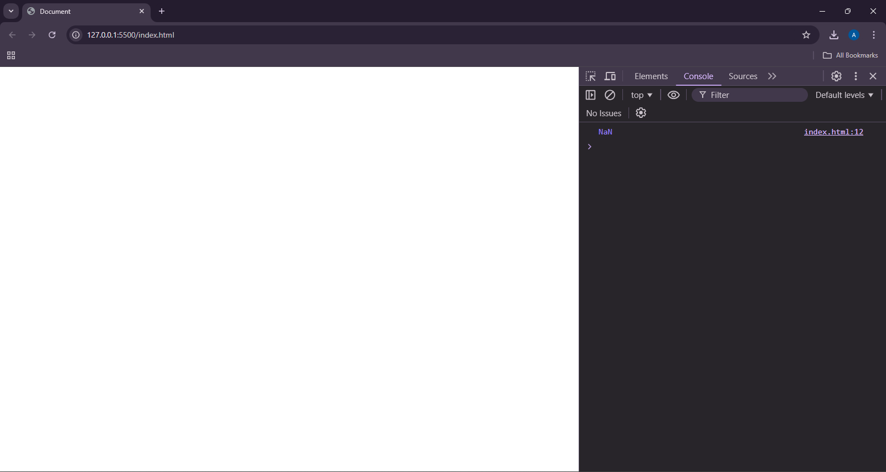

**TASK 27**

<!DOCTYPE html>

<html lang="en">

<head>

<meta charset="UTF-8">

<meta name="viewport" content="width=device-width, initial-scale=1.0">

<title>Document</title>

</head>

<body>

<script>

let empty = "";

let falseString = Boolean(empty);

let nonempty = "asdsad";

let trueString = Boolean(nonempty);

console.log(falseString);

console.log(trueString);

</script>

</body>

</html>

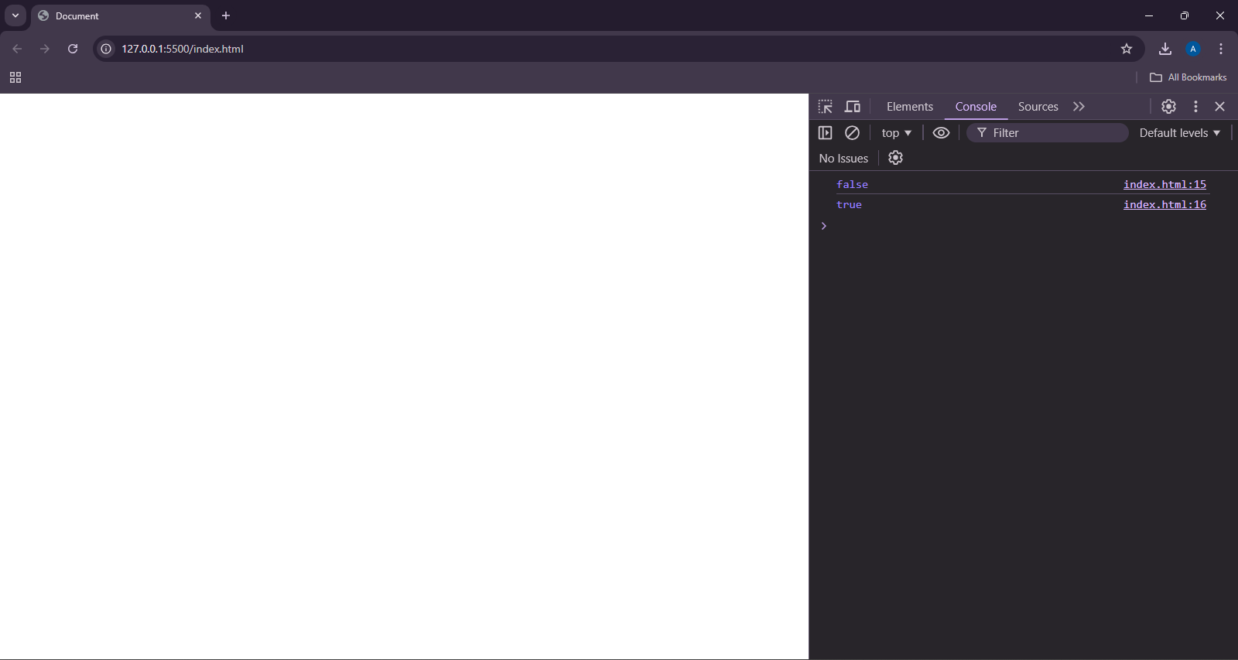

**TASK 28**

<!DOCTYPE html>

<html lang="en">

<head>

<meta charset="UTF-8">

<meta name="viewport" content="width=device-width, initial-scale=1.0">

<title>Document</title>

</head>

<body>

<script>

let a = 5, b = 9;

console.log(a + b);

console.log(a - b);

console.log(a * b);

console.log(a ** 2);

</script>

</body>

</html>

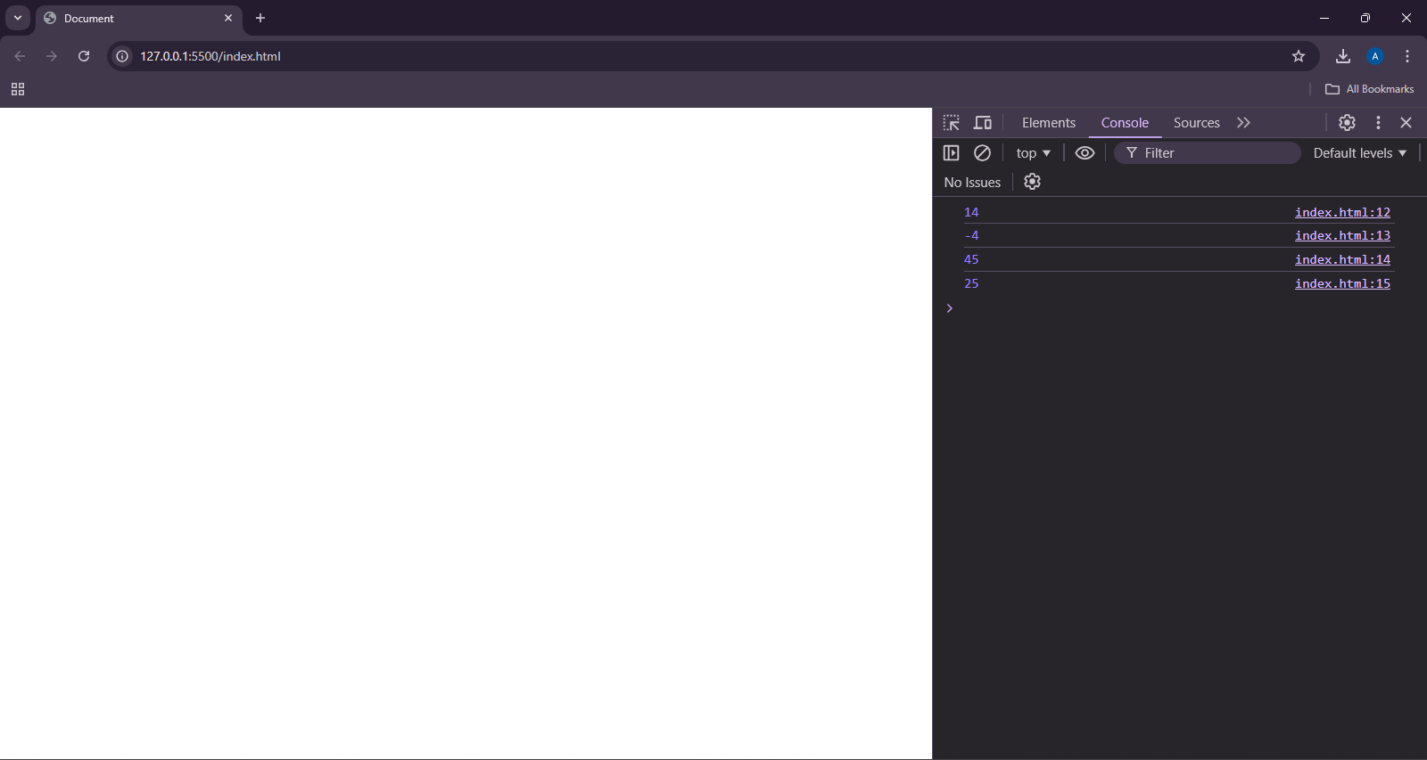

**TASK 29**

<!DOCTYPE html>

<html lang="en">

<head>

<meta charset="UTF-8">

<meta name="viewport" content="width=device-width, initial-scale=1.0">

<title>Document</title>

</head>

<body>

<script>

let a = 56;

console.log(a++);

console.log(++a);

console.log(a--);

console.log(--a);

</script>

</body>

</html>

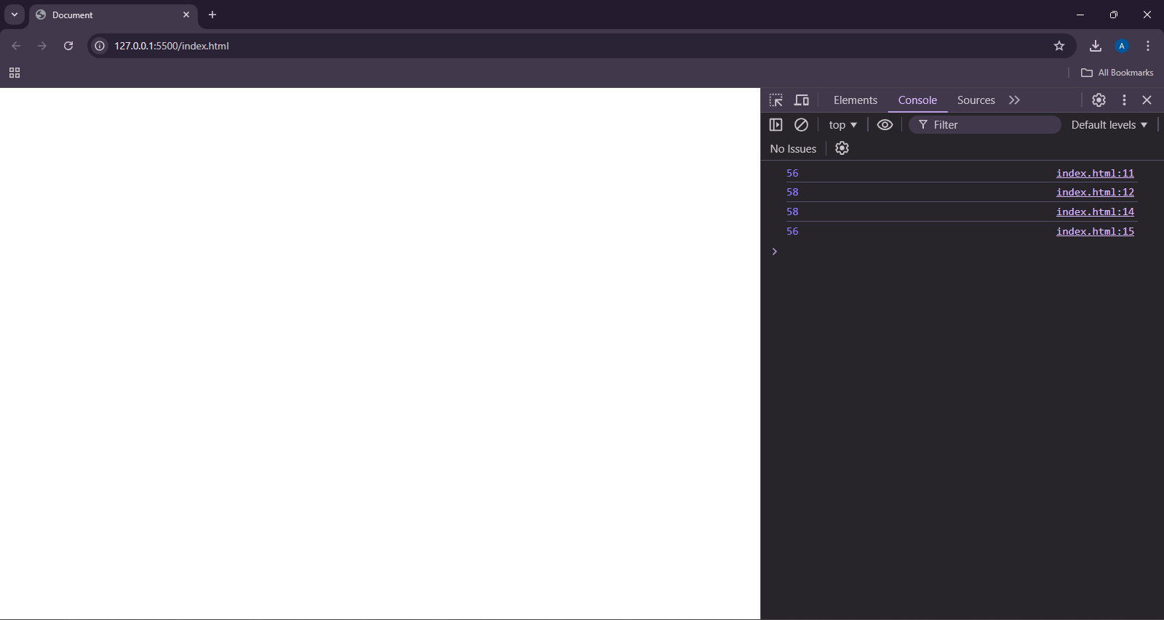

**TASK 30**

<!DOCTYPE html>

<html lang="en">

<head>

<meta charset="UTF-8">

<meta name="viewport" content="width=device-width, initial-scale=1.0">

<title>Document</title>

</head>

<body>

<script>

let a = 2, b = 9;

console.log(a - b * 2 / b ** 4);

</script>

</body>

</html>

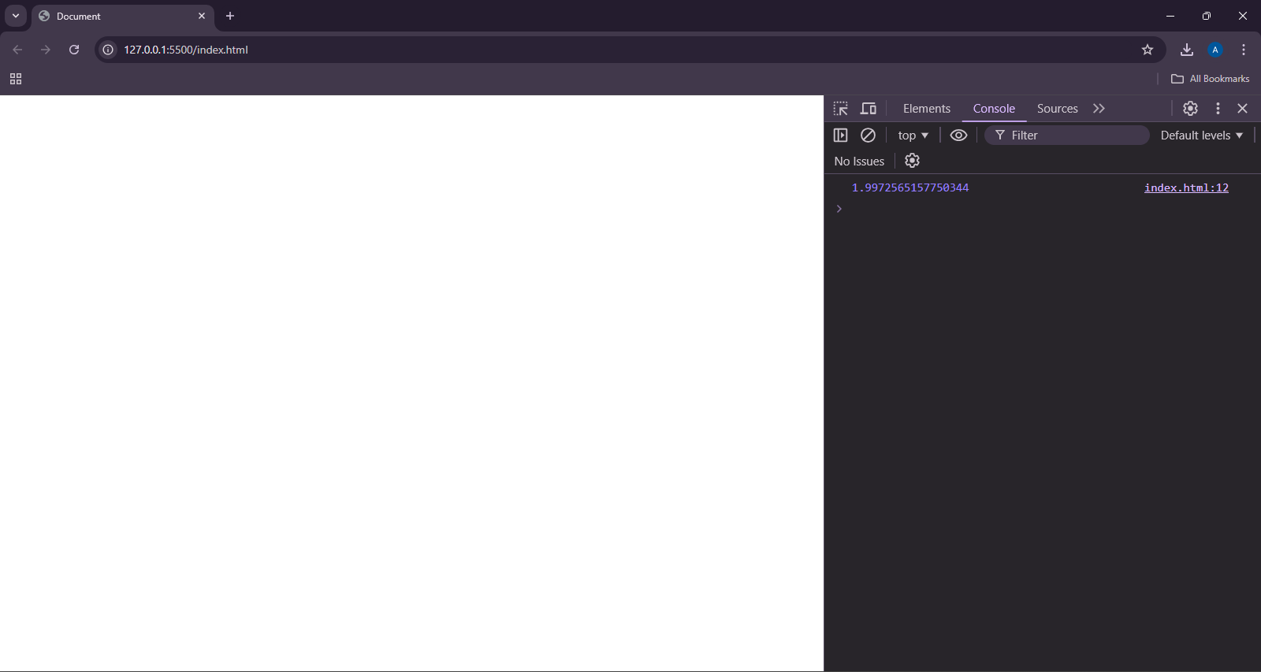

**TASK 31**

<!DOCTYPE html>

<html lang="en">

<head>

<meta charset="UTF-8">

<meta name="viewport" content="width=device-width, initial-scale=1.0">

<title>Document</title>

</head>

<body>

<script>

let a = 9, b = 2;

if(a > b){

console.log("a is greater than b");

}

a = 2, b = 9;

if(a < b){

console.log("a is less than b");

}

a = 2, b = 2;

if(a == b){

console.log("a and b are equal");

}

</script>

</body>

</html>

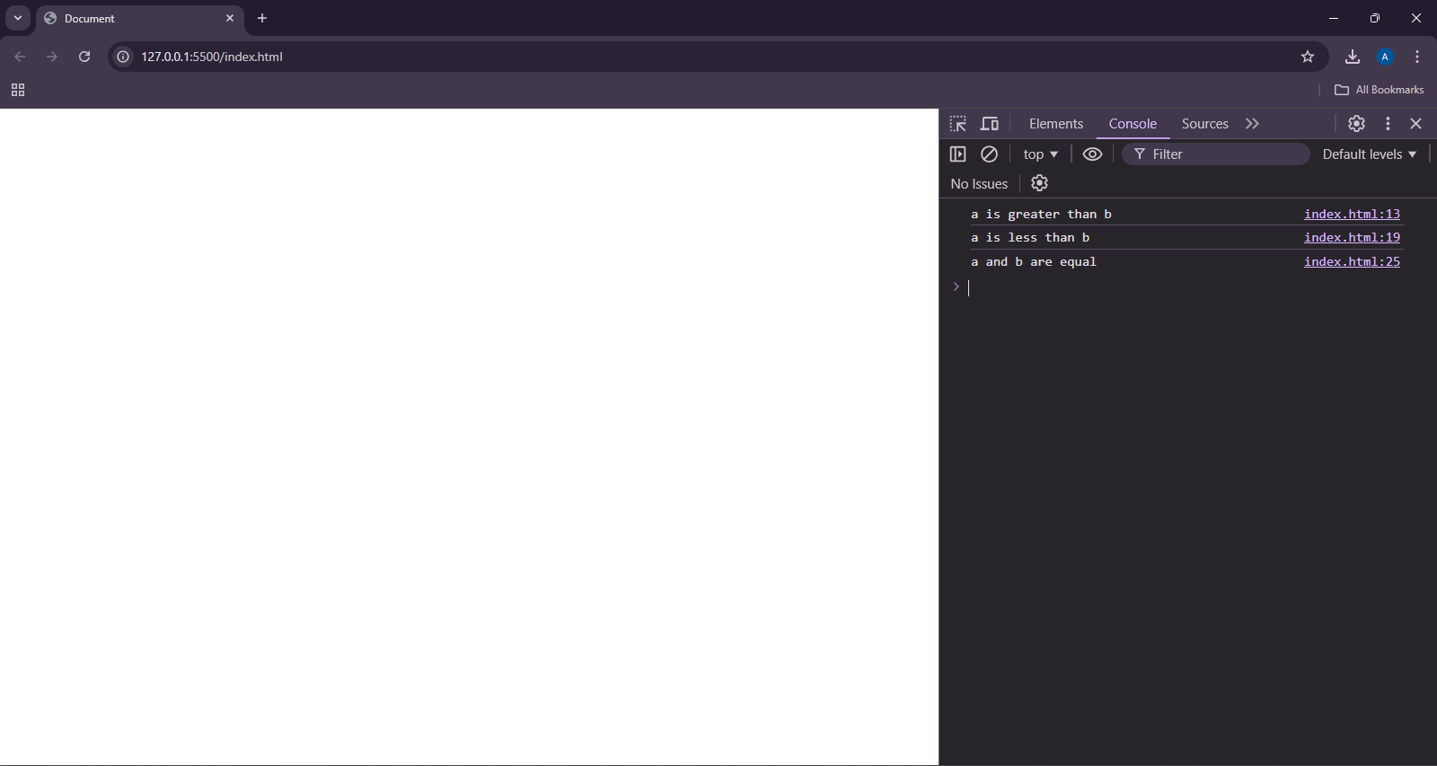

**TASK 32**

<!DOCTYPE html>

<html lang="en">

<head>

<meta charset="UTF-8">

<meta name="viewport" content="width=device-width, initial-scale=1.0">

<title>Document</title>

</head>

<body>

<script>

let a = "10", b = 10;

if(a == b){

console.log("Values of a and b are equal");

}

if(a !== b){

console.log("Values may same but data type are different");

}

</script>

</body>

</html>

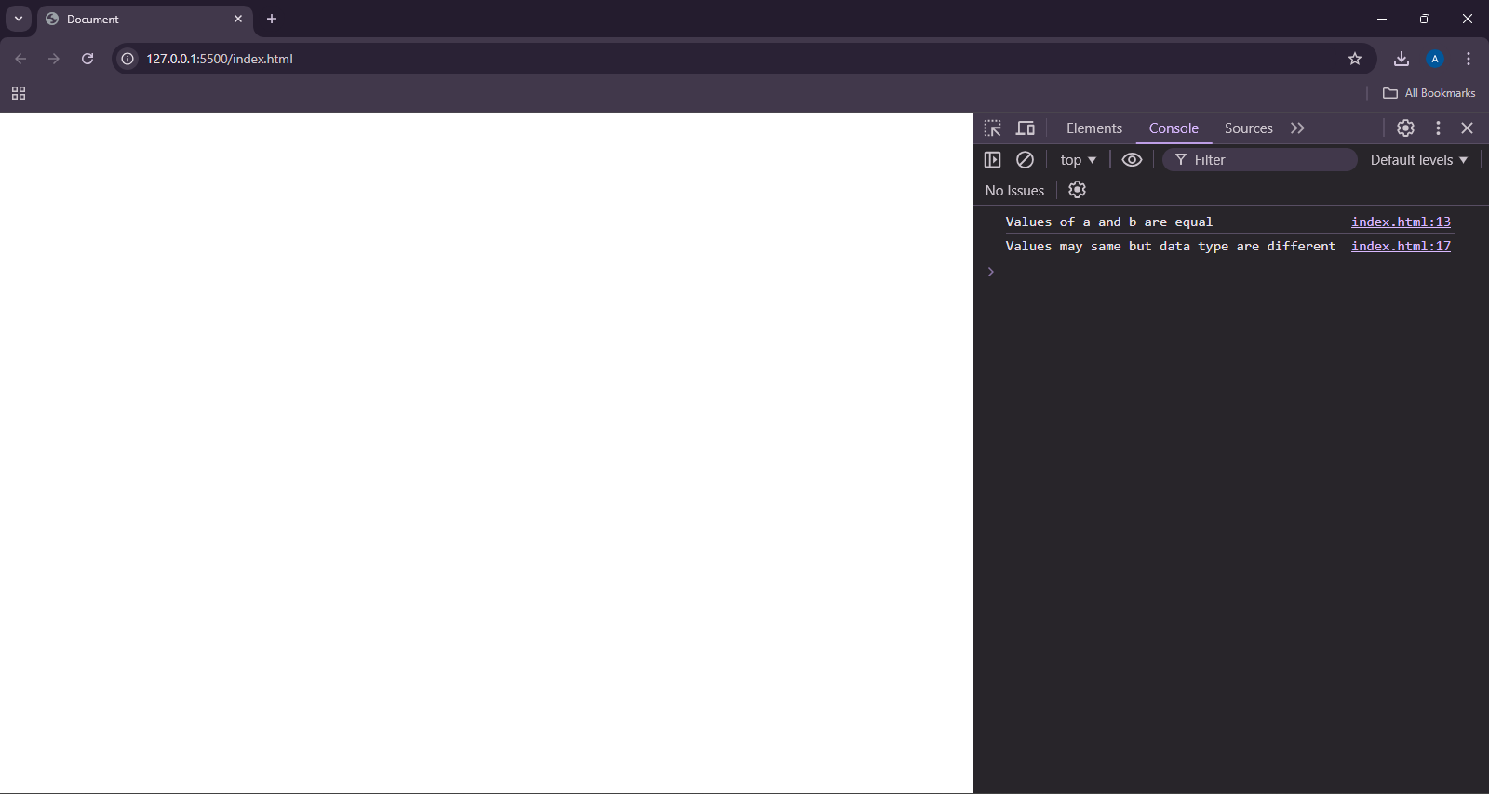

**TASK 33**

<!DOCTYPE html>

<html lang="en">

<head>

<meta charset="UTF-8">

<meta name="viewport" content="width=device-width, initial-scale=1.0">

<title>Document</title>

</head>

<body>

<script>

let first = "aa", second = "abc";

if(first < second){

console.log("First is smaller");

}else{

console.log("Second is smaller");

}

</script>

</body>

</html>

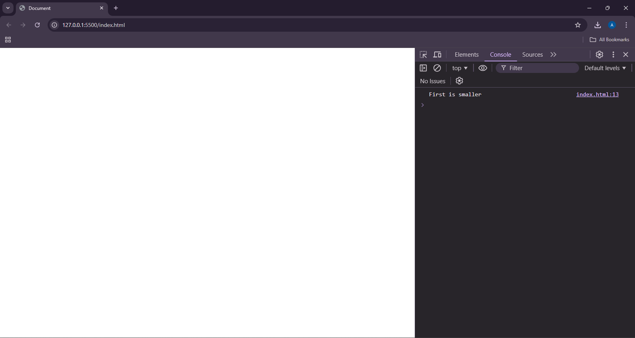

**TASK 34**

<!DOCTYPE html>

<html lang="en">

<head>

<meta charset="UTF-8">

<meta name="viewport" content="width=device-width, initial-scale=1.0">

<title>Document</title>

</head>

<body>

<script>

let a = "10", b = 10;

if(a == b){

console.log("Values of a and b are equal");

}

if(a !== b){

console.log("Values may same but data type are different");

}

</script>

</body>

</html>

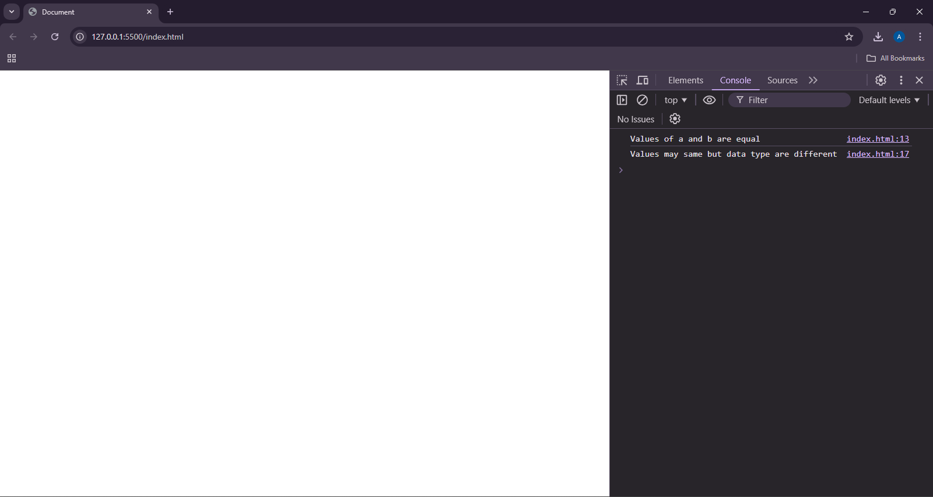

**TASK 35**

<!DOCTYPE html>

<html lang="en">

<head>

<meta charset="UTF-8">

<meta name="viewport" content="width=device-width, initial-scale=1.0">

<title>Document</title>

</head>

<body>

<script>

let nonull = null;

let nodefined;

console.log(nonull == nodefined);

</script>

</body>

</html>

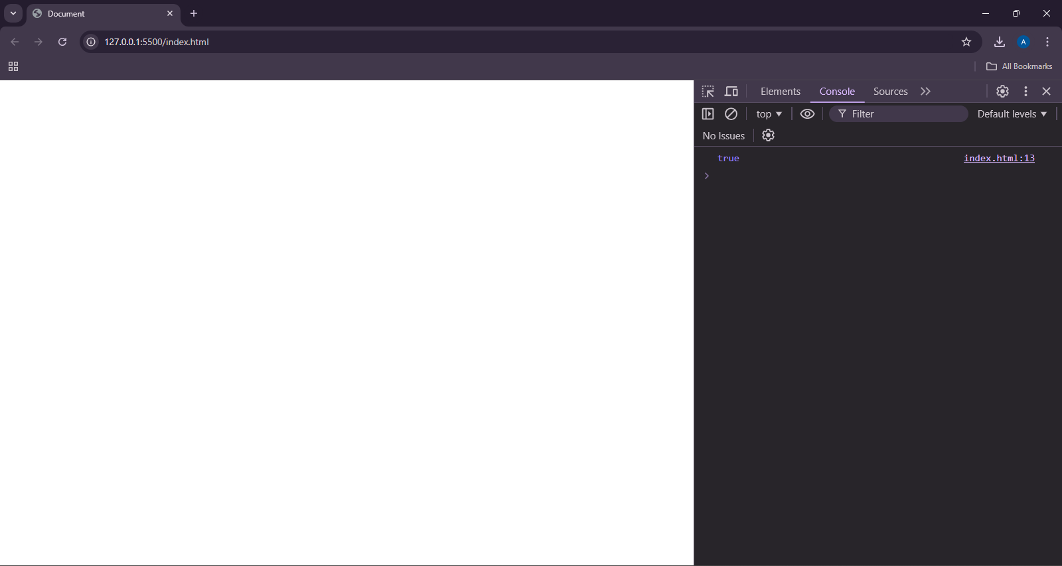

**TASK 36**

<!DOCTYPE html>

<html lang="en">

<head>

<meta charset="UTF-8">

<meta name="viewport" content="width=device-width, initial-scale=1.0">

<title>Document</title>

</head>

<body>

<script>

let num = 8;

if(num % 2 == 1){

console.log("The number is odd");

}else{

console.log("The number is even");

}

</script>

</body>

</html>

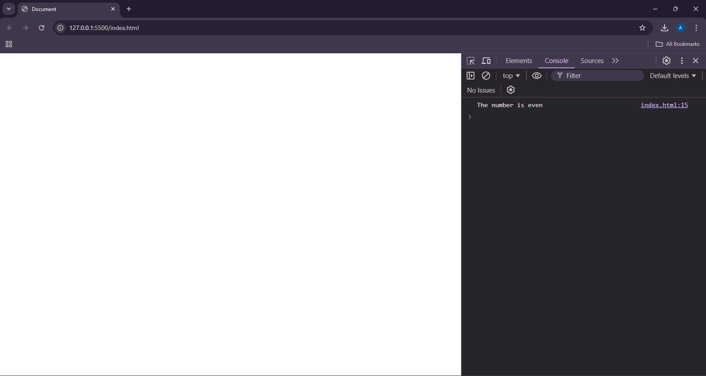

**TASK 37**

<!DOCTYPE html>

<html lang="en">

<head>

<meta charset="UTF-8">

<meta name="viewport" content="width=device-width, initial-scale=1.0">

<title>Document</title>

</head>

<body>

<script>

let num = 8;

if(num >= 0){

if(num == 0){

console.log("The given number is zero..");

}else{

console.log("The given number is positive..");

}

}else{

console.log("The given number is negative");

}

</script>

</body>

</html>

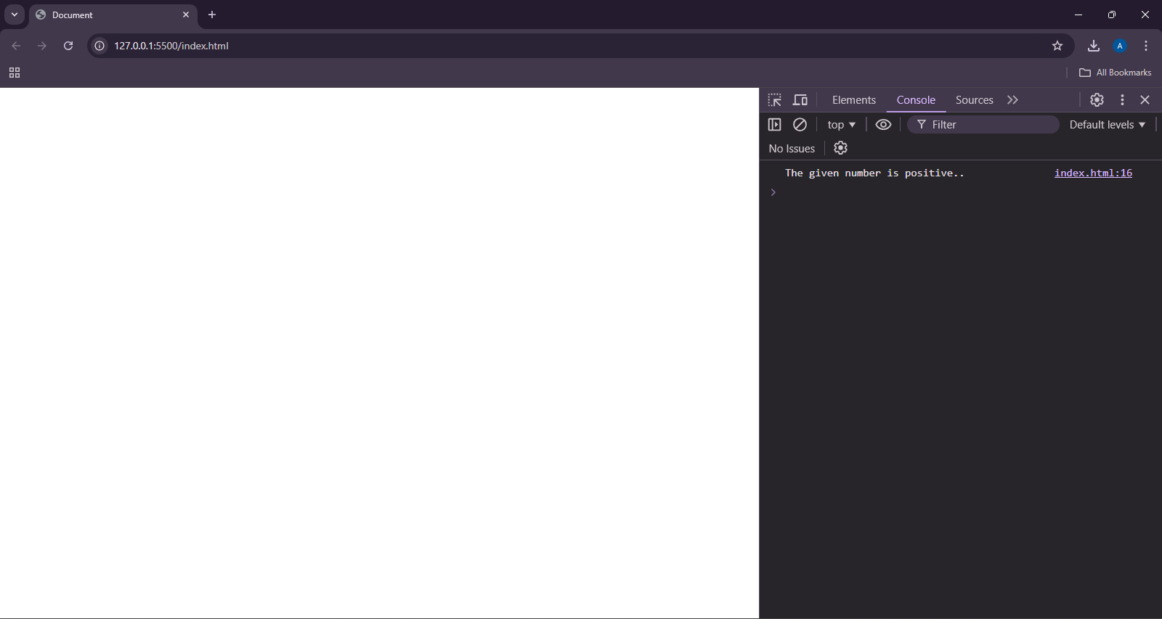

**TASK 38**

<!DOCTYPE html>

<html lang="en">

<head>

<meta charset="UTF-8">

<meta name="viewport" content="width=device-width, initial-scale=1.0">

<title>Document</title>

</head>

<body>

<script>

let num = 8;

num % 2 == 0 ? console.log("The given number is even") : console.log("The given number is odd");

</script>

</body>

</html>

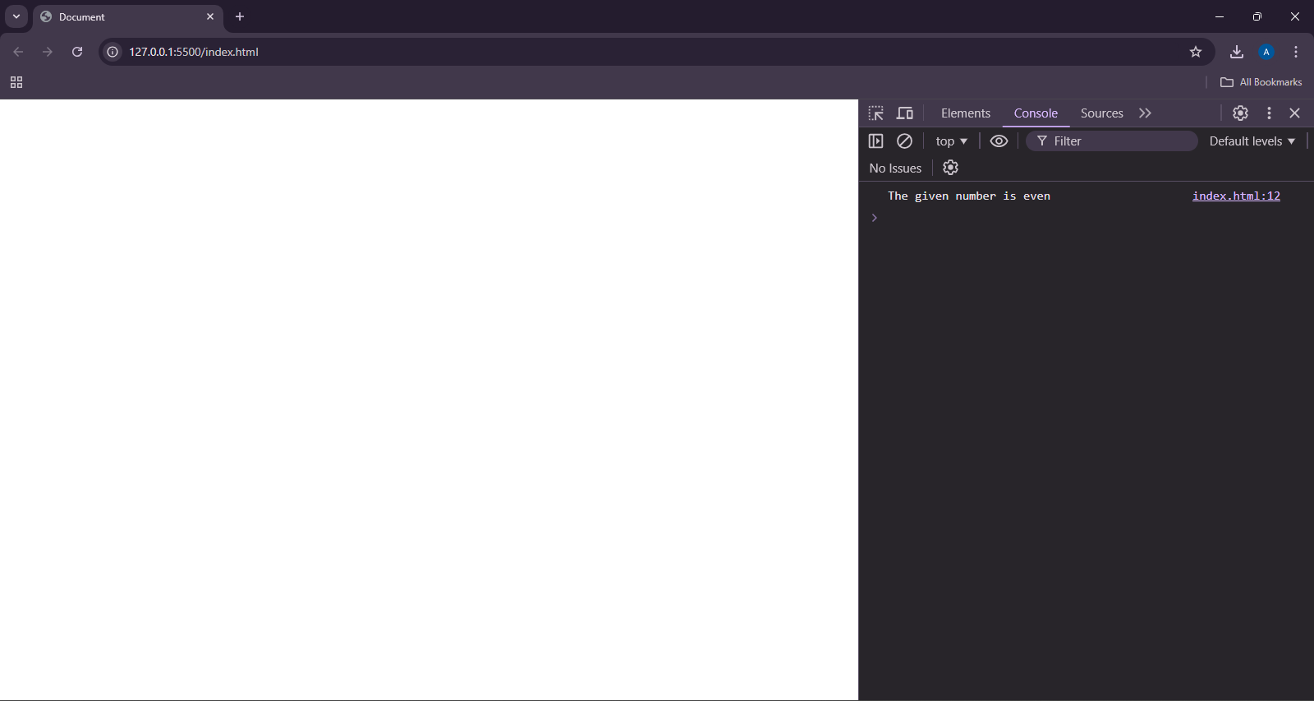

**TASK 39**

<!DOCTYPE html>

<html lang="en">

<head>

<meta charset="UTF-8">

<meta name="viewport" content="width=device-width, initial-scale=1.0">

<title>Document</title>

</head>

<body>

<script>

let num;

num ?? console.log("nodefined");

</script>

</body>

</html>

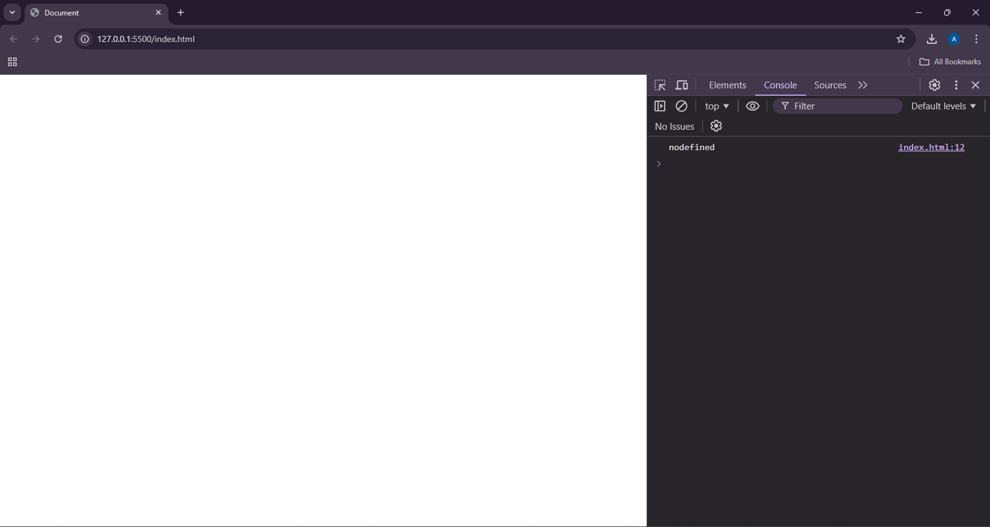

**TASK 40**

<!DOCTYPE html>

<html lang="en">

<head>

<meta charset="UTF-8">

<meta name="viewport" content="width=device-width, initial-scale=1.0">

<title>Document</title>

</head>

<body>

<script>

let num;

if(1 == 1){

num = 2;

}

console.log(num);

</script>

</body>

</html>

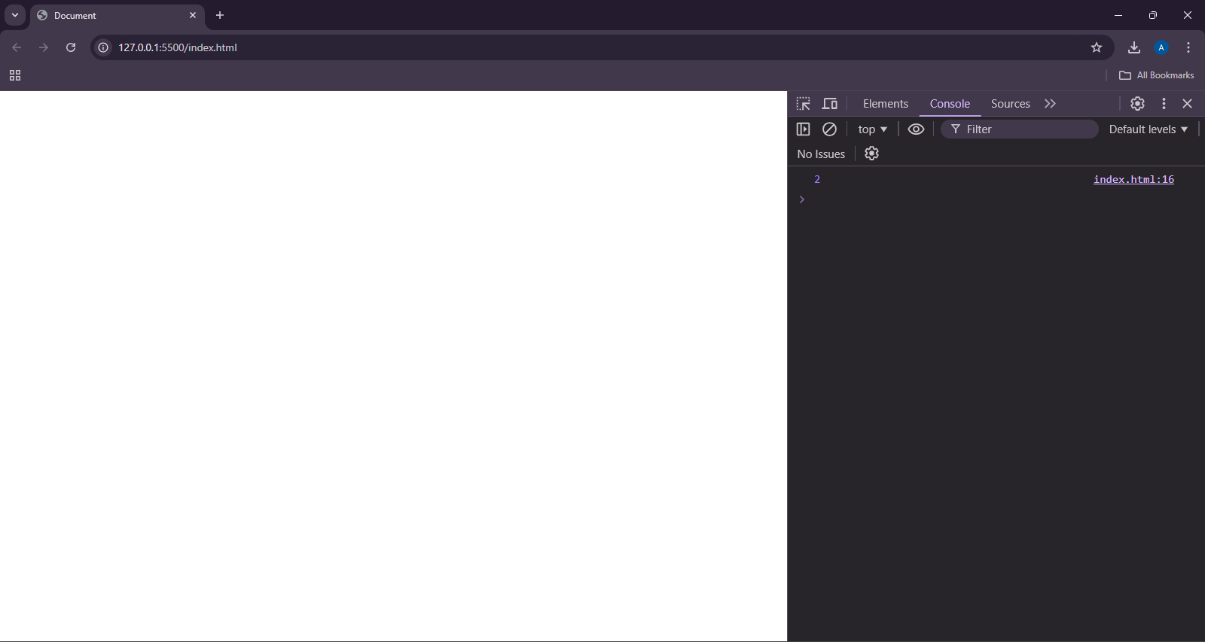

**TASK 42**

<!DOCTYPE html>

<html lang="en">

<head>

<meta charset="UTF-8">

<meta name="viewport" content="width=device-width, initial-scale=1.0">

<title>Document</title>

</head>

<body>

<script>

let start = 1, end = 10;

let num = 100;

if(num <= end && num >= start){

console.log("The number is in the range 1 to 10");

}else{

console.log("The number is not in the range");

}

</script>

</body>

</html>



**TASK 43**

<!DOCTYPE html>

<html lang="en">

<head>

<meta charset="UTF-8">

<meta name="viewport" content="width=device-width, initial-scale=1.0">

<title>Document</title>

</head>

<body>

<script>

let isAlive = false;

console.log(isAlive);

isAlive = !isAlive;

console.log(isAlive);

</script>

</body>

</html>

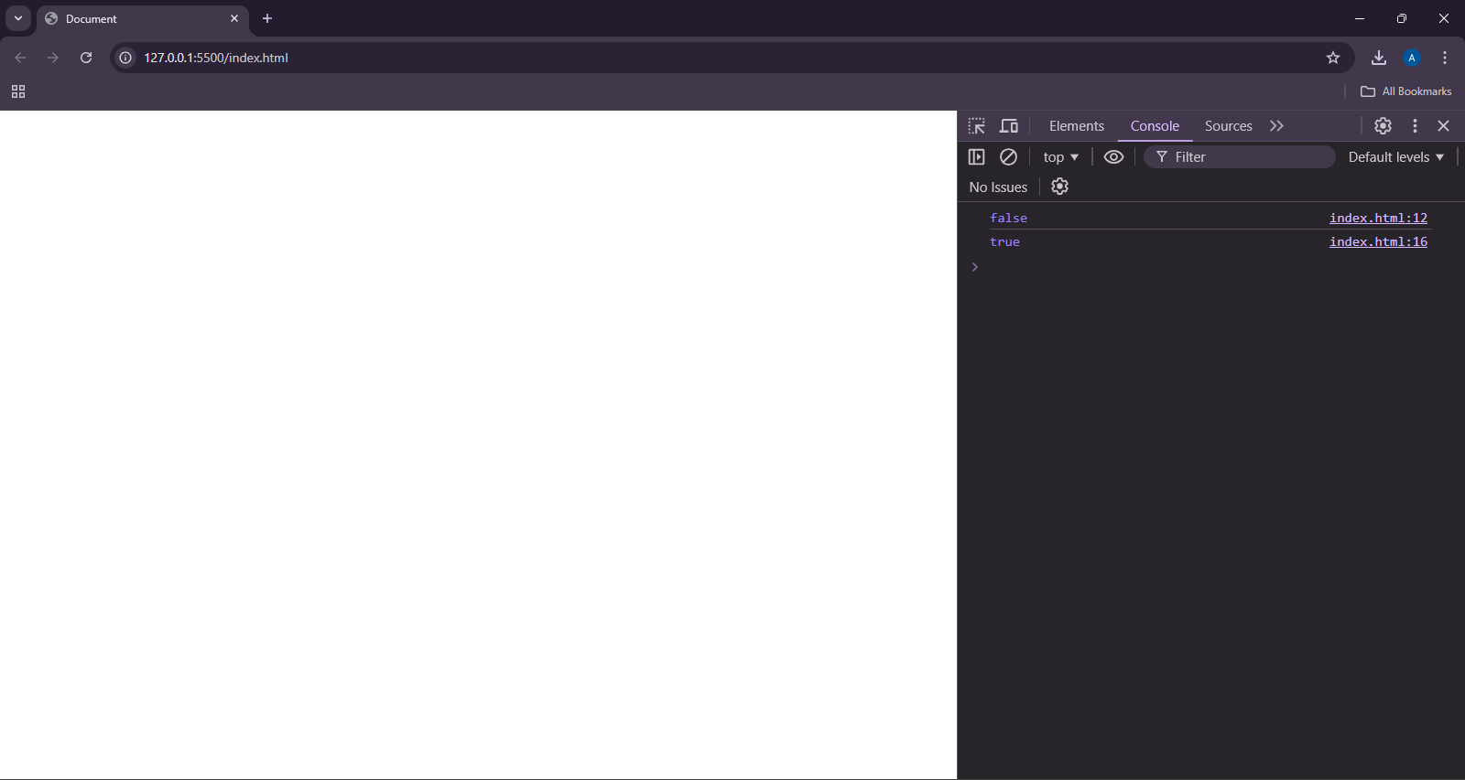

**TASK 44**

<!DOCTYPE html>

<html lang="en">

<head>

<meta charset="UTF-8">

<meta name="viewport" content="width=device-width, initial-scale=1.0">

<title>Document</title>

</head>

<body>

<script>

if(2 == 1 && 2 == 2){

console.log("INSIDE IF BLOCK");

}else{

console.log("INSIDE ELSE BLOCK 2 != 1 && 2 == 2")

}

</script>

</body>

</html>

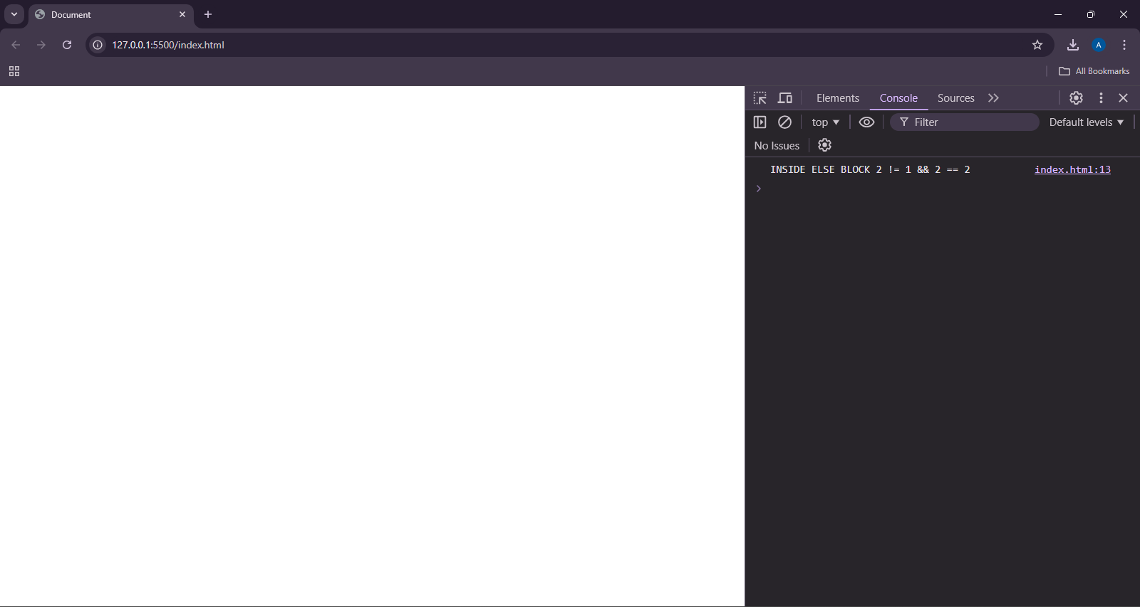

**TASK 45**

<!DOCTYPE html>

<html lang="en">

<head>

<meta charset="UTF-8">

<meta name="viewport" content="width=device-width, initial-scale=1.0">

<title>Document</title>

</head>

<body>

<script>

let firstname = "JOHN";

let number = 20;

let nonull = null;

let nodefined;

console.log(firstname == number);

console.log(nonull == nodefined);

</script>

</body>

</html>

